Using the Young People’s Communiqué

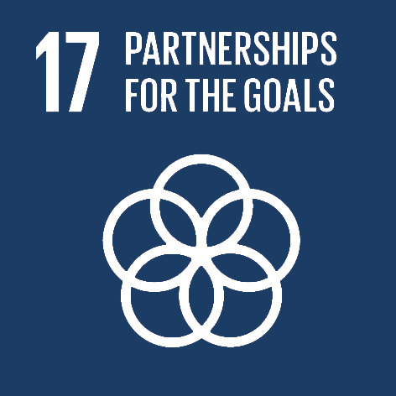
Goal 17 Strengthening and reinforcing alliances for sustainable development and its ways of implementation

The Young People’s Communiqué says:

Everyone has a responsibility for taking action, if we are to achieve the Sustainable Development Goals. Schools can play an important role in developing sustainable communities. We can use the strength of Initiatives such as eco-schools and social networks to solve local and global crisis.

We need to work in a way which gets rid of anti-development practices, which ensures wide and inclusive participation from the population, which removes discriminatory practices, and respects the fundamental rights of the population working in harmony with the environment.

We want:

- To work collaboratively with other countries, sharing what we know and learning from them

- To use social media and technology to set up networks of people working together for change

Pupil offer: to achieve this we will continue to work in our schools making local and global connections, learning from each other and collaborating to make the world a better place. We will also encourage others to do the same, now and in the future.

On the next page are some suggested activities based on the pupil offer, with spaces for your own ideas.

Find out more about this goal at https://sustainabledevelopment.un.org/sdg17

Global learning ~ lenses on the world

www.tidegloballearning.net


Copyright © Tide~ global learning. May be copied for use in your classroom.

Offer | How to make it happen?
Make local and global connections | - Set up partnerships with other schools locally and globally: contact the project partners who developed this resource, or members of your school community, to help with this  - Join international networks such as Eco Schools http://www.ecoschools.global/
Learn from each other | - Plan and run a conference for and with other schools  - Use social media to communicate and share ideas
Collaborate to make the world a better place | - Identify a common topic to work on – perhaps using the communiqué and focusing on one of the SDGs  - Use your skills and experience to run a campaign on an important issue
Encourage others to collaborate now and in the future | - Tell others in neighbouring schools about your activities  - Set up a strong school action group, making sure that there are others to take it over when you leave. See the example of the Greenlight Club in Section 2, Sustainable development.
Add your own here

